Evaluation of the impact of Stronger Families, Functional Family Therapy in Suffolk: Draft Interim Report

May 2021



**Author:**

Georgina Cowen, Senior Consultant

**Contributors:**

John Rodger, Managing Partner

Holly Turrell, Consultant

Thomas Jones, Consultant

Suffolk County Council

**CONTENTS**

**Page**

Executive Summary i

1 introduction 1

2 programme performance 5

3 features of Delivery 12

4 family changes and outcomes achieved 19

5 cost avoided measures 27

Appendix A: Family Case Studies

Appendix B: Theory of Change

Appendix C: Evaluation Framework

# Executive Summary

1. Stronger Families Functional Family Therapy (FFT) in Suffolk began in February 2019 and is delivered through a Social Impact Bond (SIB) partnership including Suffolk County Council, Bridges Outcomes Partnerships and Family Psychology Mutual.
2. The purpose of the evaluation is to address two key questions:

* Is the intervention effective in achieving intended outcomes for young people and families supported in Suffolk?
* What factors influence effectiveness in achieving intended outcomes? How has Stronger Families FFT been delivered in the Suffolk context? What works well or not so well?

1. The evaluation incorporates a rich mix of qualitative and quantitative evidence to tell the story of the therapy delivered and the journey taken by families as a result. This includes stakeholder perceptions; intervention evidence reviews (IECs) for 25 families; four family case studies which draw on triangulated perceptions from therapists, referring practitioners, and the families themselves **(Appendix A)**; and analysis of programme performance data.
2. Building on a theory of change model for Stronger Families FFT **(Appendix B)**, this evidence base facilitates an understanding of the changes experienced by families, the outcomes achieved (and adverse outcomes avoided), and the extent to which these represent added value. It is important to emphasise, however, the qualitative nature of this assessment and that we have not had the opportunity to provide a more quantifiable comparative assessment using a randomised control trial or quasi-experimental approach.

## Programme Performance

1. Since February 2019 when the programme began, 322 consultations have been undertaken and **197 cases accepted at County Resource Panel (CRP), representing 86% of referral forms received.** The initial consultation and referral process has been valuable in identifying the most appropriate cases to progress.
2. There have been some delays between acceptance and intake meetings (for 44% of cases) with **availability of referring practitioners and difficulties contacting and engaging with families** being the primary reasons cited. It is likely that many of the communication difficulties will have also been hindered in the past year by the COVID-19 pandemic and associated restrictions.
3. Currently (as of middle of April 2021), **33 families are undertaking therapy** as part of Stronger Families FFT in Suffolk; **70 have completed the full programme**; and 53 have dropped out of the programme. This **drop- out rate of 43%** has resulted from lack of engagement of families for more than half of the cases. Changes in circumstances and not being the right time were also factors impacting some cases.
4. There are **higher drop-out rates for those families subject to a CPP or with a Child in Care** at the point of referral. Stronger Families FFT in Suffolk has also been **less successful at engaging** and supporting families where theyoung person referred is **younger than 11 years old** (despite the referral criteria being for 11+, 20 cases started where the young person was 10 and under).
5. **Awareness of and engagement with the Stronger Families programme is generally good** amongst referring practitioners;and there is consistent understanding of goals and potential value, though there some perceptions of a confusing fit alongside the Family Solutions service.
6. Some stakeholders feel there is the **potential for a greater number of families to be referred** to the Stronger Families intervention; and/or for families to be engaged at an earlier stage given that some feel therapy is “**a little too late”.** There is also a potential gap in service where the Stronger Families team could be involved earlier to help encourage and engage families in the therapeutic approach.
7. Many stakeholders feel that the **referral process and mechanisms are fairly clear** and useful; though a number also point to **frustrations associated with the depth of process** and requirements for panel involvement.
8. There are some inconsistencies regarding communication between Stronger Families teams/therapists and the referring practitioner teams. In some cases, there appears to be a **strong relationship, with regular updates and inputs to Family Network meetings or CiN meetings**. In others, stakeholders point to a range of **improvements and logistical issues that could be addressed**.
9. COVID restrictions have impacted delivery during Cohort 3 (from April 2020 onwards), causing some unavoidable delays in the referral and start process. The need to **move to virtual delivery during lockdown periods has also affected the level of engagement of families and may have affected drop-out rates** for those families that had not already begun the therapy. Nevertheless, where therapy had begun, delays or changes in service (through virtual meetings, for example) have often enabled effective continuation of the service.

## Features of Delivery

1. The 25 IEC cases reviewed included 5 from Cohort 1 (referred between February to September 2019); 5 from Cohort 2 (referred between October 2019 to March 2020); and 15 from Cohort 3 (referred since April 2020). **Key characteristics of families** referred include:

* a mix of families referred across locations (Ipswich, Bury and Lowestoft); and from Social Care, Early Help and Children in Care teams;
* 14 of the referred young people were male, and 11 were female;
* commonly, the mother was the main parent/carer involved, with father, stepfather, grandparents or aunts involved as the second parent/carer.

1. **Physical and verbal aggression** from the referred young person are the **most common presenting issues** for those referred to and starting Stronger Families FFT. However, review of the more in-depth intervention evidence points to a **complex range of needs and issues** being faced by families, including:

* the young person’s and/or parent/carers’ mental health concerns;
* parenting skills and behaviour;
* a high level of conflict within the family;
* poor communication skills;
* external influences impacting negatively on the family dynamic;
* historic physical and/or emotional abuse within the family;
* experiencing and managing grief.

1. Stronger Families FFT has normally taken between 4 and 6 months to deliver, across the three phases of Engagement and Motivation, Behavioural Change and Generalisation; with an average of 13 FFT sessions delivered for the 21 completed IECs. Detailed work in these sessions takes families through **reframing and understanding behaviours and responses**; **development of communication skills, parenting approaches**, healthy routines, and grounding techniques; and a review and **recap of skills developed and how they might be used within wider contexts** and to help to sustain change. **Noticeable** **change for many families** has resulted including:

* better relationships and communication within the family;
* conflict resolution and de-escalation;
* improved behaviour from young people within families.

1. Features of the therapy that families and other stakeholders commonly identify as working particularly well, helping to make a difference for them, include:

* addressing issues with the **family all together**, rather than individually;
* focusing on the **root cause of issues**, including past traumas and outside influences on the family;
* allowing time **for self-reflection and understanding of impact** on others, as well as reframing others’ behaviours;
* helping to **develop core communication skills**, and to practise these as a family rather than separately.

1. **Aspects of delivery that influence effectiveness** include time spent and skills used by therapists to build rapport and tailor strategies; a flexible approach to engaging with individual family members; and providing individual skills development alongside family therapy where appropriate and feasible. **Parent/carer readiness and openness to engage** with the therapy has also been important in supporting the positive delivery of therapy and change achieved.
2. Some referring practitioners identified ways in which liaison with Stronger Families had positive impacts on ways of working with and supporting vulnerable families.

## Family Outcomes and Changes Achieved

1. Some key changes and outcomes arising from Stronger Families FFT in Suffolk include:

* **C1: Risky Behaviour:** There is good evidence of improved behaviours amongst young people and better approaches to parenting amongst parents/carers for **three-fifths of the completed IECs**.
* **C2: Family Functioning:** In **two-thirds of IECs**, there are indications of improvements in family functioning resulting from the therapy.
* **C3: Strengths and Difficulties:** There has been a positive change in the impact of emotional and behavioural strengths and difficulties for **just over half of the IECs**, with perceptual evidence pointing to how the therapy has helped to achieve this change.
* **O1: Avoidance of Care:** The qualitative evidence suggests that Stronger Families FFT is **contributing towards avoided care** and **a reversal of the trajectory towards care for just over half of the IECs**. Analysis of programme data also provides some indication of potential care avoidance, with a lower proportion of young people entering care from families that had completed Stronger Families FFT (6%) compared to those that had dropped out (19%).
* **O2: Engagement in Education: In one third of IECs**, there has been some improvement in the young person’s engagement with education and/or attendance at school.
* **O3: Health:** Review of OQ45.2 scores points to some improvements in parent/carer mental health for **just over a quarter of IECs**. Similarly, for young people positive change (evidenced from Core 10 scores) is observed in **15% of IECs**.
* **O4: Offending:** There are some **qualitative references to the young people referred being less at risk** to being exploited or involved in criminal activity at the end of therapy.

# introduction

* 1. This interim report outlines the emerging findings and issues arising from an impact evaluation of the delivery of Stronger Families Function Family Therapy in Suffolk.

## Stronger Families Functional Family Therapy in Suffolk

* 1. The Stronger Families intervention is intended to enable some specialist support, providing therapy directly to families, helping them to adjust, heal and build relationships in the *“face of devastating problems, such as violence, abuse and neglect”[1]*. It is designed to support young people at risk of care (or custody) as a result of parental abuse or neglect; and/or complex behavioural problems. The intensive therapeutic intervention offered through Functional Family Therapy (FFT) is intended to help repair relationships, help families communicate better and help parents better support and influence their children.
  2. Stronger Families FFT in Suffolk is delivered through a Social Impact Bond (SIB) partnership including Suffolk County Council, Bridges Outcomes Partnerships and Family Psychology Mutual. FFT is delivered in Suffolk with therapists embedded within their children and family social work teams. Therapists provide home-based family therapy sessions with young people and their families from 8 to 26 weeks. In Suffolk referrals are primarily for young people between the ages of 11 and 18 (through a small number of referrals have been made for 6 to 10-year-olds).
  3. Functional Family Therapy (FFT) is an evidence-based programme, seeking to address problematic family relationships and resultant behaviours with a strengths-based relational approach. It includes three phases:
  + **Engagement and Motivation:** This phase concentrates on motivating the family to actively engage in the therapy by reducing blame and negativity and building alliance within the family.
  + **Behaviour Change:** This stage builds on the alliance created within the family and teaches the family new skills for managing challenges together.
  + **Generalisation:** This phase supports the family in applying the skills learned to new situations inside and outside the home thus embedding permanent change.

## Suffolk Context

* 1. There are around 5000 Children in contact with Social Care and Early Help services in Suffolk, including over 900 Children in Care (CIC), 500 on a child protection plan (CPP), just under 2,000 Children in Need (CIN) and 1,600 with an open Children Assessment Framework (CAF).
  2. The number of CIC and CPP continued to steadily increase between April 2019 and February 2021 following four preceding years of growth. The number of Children is Need has fluctuated considerably over the period and is currently back at a similar level to April 2019. The number of children with an open CAF has reduced.



* 1. There has been a small decrease in the average number of 11+ year olds entering care per month over the period 2016 to 2019, compared to 2019 to 2021.

Table 1.1: Suffolk Average Monthly Children into Care by Age Group

|  |  |  |
| --- | --- | --- |
|  | **2016 to 2019** | **2019 to 2021** |
| 0-1 | 7.4 | 8.2 |
| 2-10 | 8.5 | 9.2 |
| 11+ | 9.1 | 8.2 |

Source: Suffolk County Council Data, April 2021

## Evaluation Approach

* 1. The purpose of the evaluation is to address two key questions:
  + **Is the intervention effective in achieving intended outcomes** young people and families supported in Suffolk?
  + **What factors influence effectiveness in achieving intended outcomes?** How has Stronger Families FFT been delivered in the Suffolk context? What works well or not so well?
  1. The evaluation incorporates a rich mix of qualitative and quantitative evidence to tell the story of the therapy delivered and the journey taken by families as a result, including:
  + **Stakeholder perceptions** –referring practitioners, therapists, service leads and managers (Social Care, Early Help, Stronger Families).
  + **Intervention evidence review for 25 families** – social care status, family context/characteristics and needs (family functioning and referral behaviours), intervention steps and activities, changes and outcomes resulting for families.
  + **Four family case studies** which draw on triangulated perceptions from therapists, referring practitioners, and the families themselves (parents/carers, young people and siblings) – evidence from each individual case study is included in **Appendix A**.
  + **Analysis of programme performance data** – referrals, starts, completions, drop out, and delays.
  1. Building on a theory of change model for Stronger Families FFT (**Appendix B**), this evidence base facilitates an understanding of the changes experienced by families, the outcomes achieved (and adverse outcomes avoided), and the extent to which these represent added value; including some quantitative assessment of changes relating to intended outcomes including risky behaviours (young people and parents/carers); family functioning; avoided care; mental health; education attendance; and offending behaviour.
  2. A longitudinal assessment will be provided in later stages of the research where we will undertake follow up interviews with the case study families and access updated data on social care status, education and offending outcomes for the families engaged. This will further our understanding of the added value and sustainability of outcomes achieved for the families engaged.

#### Attribution

* 1. Throughout, we use triangulated quantitative and qualitative evidence to provide an assessment of the outcomes achieved, and some understanding of the attribution of SF FFT towards these outcomes, and in particular the avoidance of care. It is important to recognise that, whilst we provide some comparative comment (for example in relation to the care status of those families that have dropped out of Stronger Families FFT), we have not had the opportunity to provide a more quantifiable comparative assessment using a randomised control trial or quasi-experimental approach.

#### Data Constraints

* 1. We accessed a range of quantifiable and qualitative data about 25 families (purposively sampled across cohorts, locations, and social care/Early Help teams). Data was obtained from Suffolk County Council’s LCS (including social care status, intervention case notes, referral and closure forms); and the Stronger Families IAPTUS database (including validated clinical assessment tools for strengths and difficulties, family functioning and mental health; and satisfaction questionnaires).
  2. In accessing and reviewing this data it is evident that there is some inconsistency in style, quality and approach to recording evidence for families supported through Stronger Families FFT. We are aware that the approach to recording case notes on LCS has been changed over the lifetime of the intervention, and that recording referral behaviours within referral and closure forms was only introduced later in 2020. As a result, we have **faced some constraints in our assessment** of some of this evidence including:
  + There has **not always been consistently available a referral and closure form for each case**, in a consistent format, for each of the 25 cases. It was necessary to supplement information from case notes where available to fill in some of the gaps.
  + We were able to capture some data on referral behaviours at the start, and again at the end (more recently including a rating of severity score) of the intervention. However, this was **only for a small number of the 25 cases, and it is not clear how behaviours have changed** – better, worse etc from the data that we have seen. In order to provide some assessment of the change in referral behaviours in Section 4, therefore, it has been necessary to draw on the more qualitative evidence from case notes, closure forms, and satisfaction questionnaire responses.
  + Data on **education and offending outcomes is not readily accessible** from the referral or closure forms that we have seen. Some did include a reference to less than 90% attendance; and some provided a better/worse comment on the closure form. However, this was not comprehensive or consistent.
  + Completed pre and post questionnaires for the **validated clinical assessment tools** (SDQs, Core 10, Score 15 and OQ45.2) were available for around **two-thirds of the 21 completed cases** included in our sample. **Satisfaction questionnaires** were available for **just 7, 12 and 13 referrers, parents and young people** respectively.

# programme performance

* 1. In this section we provide an overview of the number of families referred to and supported through Stronger Families FFT in Suffolk to date (between February 2019 and April 2021). We also outline some of the issues and factors influencing performance and effectiveness at the programme level.

## Programme Activity

* 1. Since the programme began in February 2019, Stronger Families have participated in 322 consultations with referring practitioners, considering whether the families concerned should be referred to the programme. 229 referral forms were subsequently completed by Social Care or Early Help practitioners.
  2. 204 progressed to County Resource Panel (CRP), where **197 were accepted** at this point – **61% of those initially consulted upon; and 86% of referral forms received**. Whilst reasons are provided for ‘unsuccessful’ consultations within the programme data, the majority of these have been entered as ‘other’, and so it is not clear why families have not progressed at this point. Where reasons are provided, they tend to be due to lack of parent/carer or young person engagement (10 cases) or they have declined the service (5 cases); because specific referral criteria have not been met (10 cases); or an alternate service (4 cases) has been identified.
  3. Just seven cases had not been accepted by CRP (commonly because an alternate service is deemed appropriate). This suggests that **the initial consultation and referral process have been a valuable part of the process**, in identifying the most appropriate cases to progress at this stage. This is also reflected in some of the stakeholder perceptions:

“The two-way conversation before filling in the referral form helps to frame the discussion at panel”.

* 1. **180 intake meetings have been held with families (91% of those accepted at CRP)**, and of these:
  + 17 were not accepted by the family or therapist at this point - ‘unsuitable starts’ - often due to lack of engagement by the parent/carer or young person;
  + 7 were re-referred;
  + 156 started the intervention.
  1. There was a delay between CRP and intake for 80 cases (44%) – for one third there were **constraints associated with the availability of the referring practitioner**; and for another third, there were **difficulties in contacting or engaging the family**.
  2. **COVID restrictions** have only been explicitly cited as reasons for delay or withdrawal from the intervention in a small number (six) of cases; though they may of course, underlie some of the communication difficulties to engage in the intake sessions.
  3. **33 families are currently undertaking the intervention**. Of the 123 cases that have finished therapy, **70 completed the therapy in full** and **53 dropped out**, representing a drop-out **rate of 43%**.

Table 2.1: Reasons for Drop-Out after Intake Meeting

|  |  |
| --- | --- |
|  | **% Proportion of Dropouts where reason given (n=44)** |
| Lack of engagement from family/family withdrew – parents/carers, young person, or both | 48% |
| Impact of COVID restrictions (e.g., virtual working) | 2% |
| Change in circumstances of family and/or change in view from professionals of suitability for Stronger Families | 27% |
| Not the right time for FFT | 18% |
| Other | 5% |

Source: Suffolk County Council Stronger Families Programme Data, April 2021

* 1. 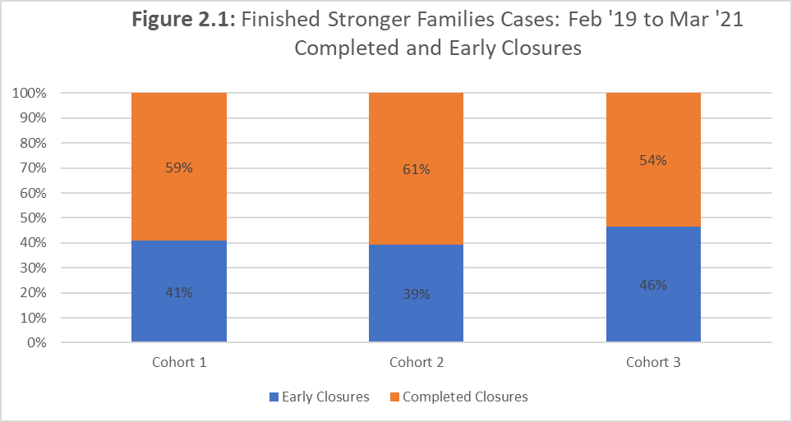For over half of cases, the reason for drop out was **lack of engagement from the family** (including 11 ‘unsuitable starts’, where the parent/carer declined prior to the first meeting). In around one quarter of cases, there was a **change in circumstances and/or the professionals changed their view** on the suitability of the family for FFT; and for 18% it was **not considered to be the right time** for the intervention for this family. Again, whilst not explicit in the comments, it is likely that COVID restrictions may have impacted on this last group to some extent, with drop out in Cohort 3[2] (referred since April 2020) being slightly higher than previous cohorts.

Source: Suffolk County Council Stronger Families Programme Data, April 2021

* 1. Amongst those cases that have finished Stronger Families FFT in Suffolk, there are higher drop-out rates for those families on a CPP or with a child in care (CIC) at the point of referral. The highest success rates are for those families with an open CAF at the point of referral, followed by those identified as CIN.

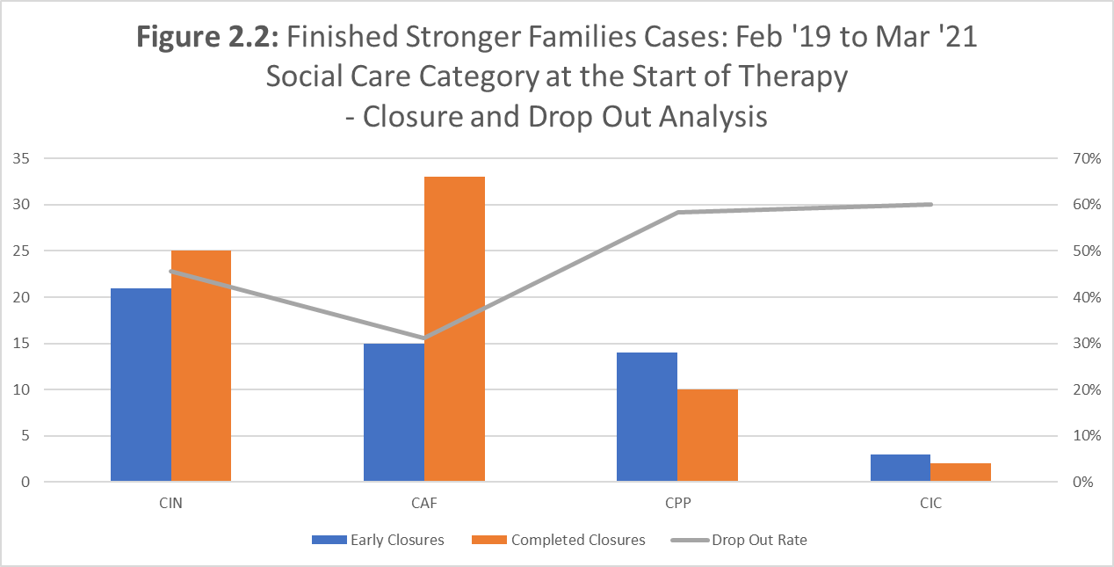

Source: Suffolk County Council Stronger Families Programme Data, April 2021

* 1. Figure 2.3 shows the age profile of the referred young person in each of the closed cases in Suffolk. This suggests that Stronger Families FFT in Suffolk has been less successful at engaging and supporting families where the young person referred is younger than 11 years old, with high drop-out rates for these families.

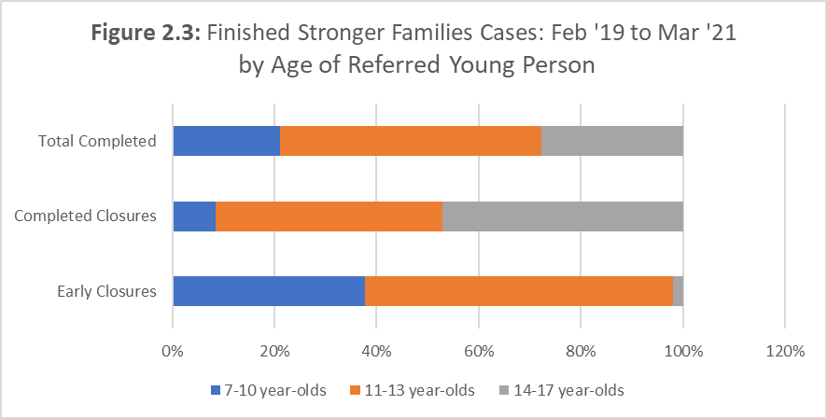

Source: Suffolk County Council Stronger Families Programme Data, April 2021

* 1. Whilst the referral criteria suggest referred young people should be aged 11 or more, 20 cases have involved younger children. Only 5 of these families have successfully completed the therapy and these involved 10-year-olds.

## Factors Influencing Programme Effectiveness

* 1. **Awareness of and engagement with the Stronger Families programme is generally good** amongst those stakeholders consulted through the research. Service leads and referring practitioners have pointed to the value of communications from the Stronger Families team in the form of emails, presentations of *“dos and don’ts”*, and therapists attending Social Care and Early Help team meetings.

“We feel fairly confident in what the service can offer, and we are confident that we can have informal consultations about particular cases and why they are appropriate for the service”.

“The Stronger Families team came to our team meeting to explain the types of family appropriate for referral – I was aware before, but it was helpful to have this refresher session”.

* 1. There do remain some perceptions, however, indicating some confusion about the fit of Stronger Families alongside the Family Solutions service.

“I sometimes get confused about the difference between Stronger Families and Family Solutions. Their similar names make it harder to adequately explain the intervention to families”.

* 1. There appear to be **consistent views on the goals and potential added value** of Stronger Families. Key features identified by those we interviewed include:
  + Ultimate aims to keep families together and avoid care.
  + Unique selling point of the whole family focus.
  + Emphasis on relationships with therapeutic, restorative and systemic approaches - enabling attention to social and emotional concerns; and well-being.
  + Tailored skills development, motivational strategies and solutions identification.
  1. Some views have been expressed (from around half of those consulted) that there may be the **potential for a greater number of families to be referred to the Stronger Families intervention**. A review by one Head of Service identified that 25 of 30 recent into-care cases could potentially have been referred to Stronger Families.

“I would refer more if there was greater capacity in the team – Stronger Families definitely fills a gap”.

“There are few services for family therapy that are free, we need to expand this service”.

* 1. Equally, feedback from some stakeholders (therapists, referring practitioners and families from completed cases) suggests some families should have been referred at an earlier stage; and that **sometimes the therapy is *“a little too late”*** for the family.

“Thinking back on previous cases, it would have been really useful to have this service – and to be able to refer at a younger age, before getting to edge of care”.

* 1. These perceptions, taken together with the programme data showing that drop-out (before and after a start) commonly results from lack of family engagement, point to a potential gap in service. **Could the Stronger Families team be involved earlier to encourage and help families to understand what would be involved**; to support families to more readily engage in the therapy?

“Having a member of the Stronger Families team talk to the families before panel would be really helpful as it may set a better tone and let them know what to expect”.

### Referral Practice

* 1. Some stakeholders feel that the referral process and mechanisms are fairly clear and useful.

“There is a clear process of referral – we know what to do – consultation, fill out form if threshold met, go to resource panel”.

“This is one of the best referral processes ever – extremely quick”.

“The two-way conversation between Early Help and Stronger Families before filling in the referral form helps to frame the discussion at panel”.

“It’s really beneficial for the case worker to present at panel”.

“The process of applying is very clear. I am aware of the service and what they do. I can explain to the families – and sell it a bit when families are in crisis”.

* 1. There are a number, however, who point to some frustrations, and potential improvements.

“The referral form is very long with lots of detail required – it takes a lot of time from social workers, that they do not always have”.

“The application process is quite scary if you’re not experienced. Having to sit in front of the panel and explain your case, it’s like going for interview”.

“The requirement to attend the CRP is a challenge”.

“The panel process is a pain and there have been delays for a couple of cases, which impacted on engagement for the family”.

“Greater flexibility and/or warning of dates for panels would be beneficial – for staff, especially those who are part time, to make arrangements to attend”.

“I find it easier to refer to Family Solutions. They have no panel, and our team are linked more closely with them. They are more on my radar when I’m thinking of avenues to improve family functioning”.

“We had to go through the referral process twice to change the referral to the sibling of the original young person – it would have been better if we could have just transferred across. This caused unnecessary delays and potentially impacted on overall engagement and effectiveness as a result”.

### Service Liaison

* 1. There are some inconsistencies regarding communication between Stronger Families teams/therapists and the referring practitioner teams. In some cases, there appears to be a strong relationship, with regular updates and inputs to Family Network meetings or CiN meetings.

“It was really helpful when the therapist came to family network meetings to discuss progress”.

“Communication with the Stronger Families team is always very positive, and the team manager is always approachable”.

“As they are embedded it’s easy to work with Stronger Families as they feel like colleagues”.

“The therapist was incredibly understanding, proactive, helpful and approachable, checking in with updates about the family regularly”.

* 1. In other cases, stakeholders point to a range of improvements that could be made.

“I was not aware for a long time that Stronger Families logged case notes on their social work system. I would phone the therapist for verbal updates not realising I could see them on LCS. It would have been helpful to have this feature of the service marketed so I/others could use the updates when speaking with the families”.

“It would have been helpful to have a summary of what was included in each session”.

* 1. There are also some logistical issues for consideration:

“Sometimes cases which need to be closed or stepped down can’t until the Stronger Families intervention has stopped which is frustrating as it can cause confusion and lack of planning”.

“There is a grey area about the role of Early Help for some Stronger Families cases – a CAF is opened so that they can access Stronger Families, but it is not clear that we have a role to play, so we are just holding the case for them”.

“It would have been helpful for the therapist to be able to liaise with the young person’s mental health worker”.

### COVID

* 1. As already referenced, the COVID-19 pandemic affected programme delivery during Cohort 3 (from April 2020), causing some unavoidable delays in the referral and start process. The need to move to virtual delivery during lockdown periods also influenced the level of engagement of families and may have affected drop- out rates for those families that had not already begun the therapy.

“The family didn’t engage well at all – the need for virtual sessions at the start did not help and made them too formal. They would have coped much better if sessions were delivered face to face”.

“Moving to virtual has caused a real problem with children engaging in the therapy – the two youngest completely disengaged. Face to face would really have helped here”.

* 1. Nevertheless, where therapy had already begun before lockdown, any delay or change in service (through virtual meetings, for example) did not affect family engagement as much when therapists had not already had a chance to meet and engage the families.

“The first therapist contracted COVID and went on long-term sick. There were concerns over whether the family would engage with the new therapist, but because they had already had a few sessions and it was a really positive experience, they were able to translate and transfer the positivity to the next therapist”.

“The family preferred face to face but felt adapted well to virtual support because they had already built a strong rapport with the therapist”.

# features of Delivery

* 1. Here we provide a description of Stronger Families FFT in Suffolk, including comment on factors impacting on the effectiveness of delivery. We draw on evidence from the Intervention Evidence Cases (IECs), Family Case Studies, and interviews with referring practitioners and therapists.

## Family Context and Behaviour Profile

### Characteristics

* 1. The 25 IEC cases reviewed included 5 from Cohort 1 (referred between February to September 2019); 5 from Cohort 2 (referred between October 2019 to March 2020); and 15 from Cohort 3 (referred since April 2020).
  2. They included 14 families referred from Social Care, 9 from Early Help and 2 from Children in Care teams. 12 families were from Ipswich, 8 from Bury and 5 from Lowestoft. 14 of the referred young people were male, and 11 were female.
  3. 14 cases involved two or more parent/carers. Commonly, the mother was the main parent/carer involved, with father, stepfather, grandparents or aunts involved as the second parent/carer.

### Presenting Issue

* 1. Physical and verbal aggression from the referred young person are the most common presenting issues for families who have been referred to and started the Stronger Families FFT intervention.

Table 3.1: Presenting Issues - Stronger Families FFT

|  |  |  |
| --- | --- | --- |
|  | **Proportion of Starts Feb ’19 to Mar’21** | **Number (proportion) of Intervention Evidence Cases** |
| Physically aggressive | 39% | 4 (16 %) |
| Verbally aggressive | 34% | 8 (32%) |
| Experiences poor parental behaviour e.g., neglect | 6% | 2 (8%) |
| Absconds/ Goes Missing | 7% | 2(8%) |
| Young Person Mental Health (includes self-harming, struggles with self-identity) | 4.4% | 3(12%) |
| Young Person Risky Behaviour (includes drugs, alcohol, at risk of/engaging in CSE) | 5.7% | 1(4%) |
| Young Person Criminal Behaviour (includes criminal behaviour, threats of harm to others, at risk of criminal exploitation) | 3.8% | 5(20%) |

Source: Suffolk County Council Stronger Families Programme Data, April 2021

### Family Needs and Issues

* 1. Nevertheless, a review of the more in-depth intervention evidence points to a more complex range of needs and issues being faced by families. In particular, mental health concerns for the referred young people are more prevalent than suggested by the “tick one option” presenting issue analysis. Across the intervention evidence cases (IECs):
  + 20 included referring issues linked to the **child’s mental health**, including low mood, low self-esteem, struggles with self-identify, risk of self-harm and exploitation.
  + 16 referenced the **young person’s behaviour** including struggles with emotional regulation, verbal and/or physical aggression, homelife disruption, and some drugs/police involvement.
  + 10 identified **parenting skills and behaviour** as a concern, including inconsistent parenting and parental response perpetuating behaviours.
  + Six indicated a **high level of conflict** between children and parents and/or between siblings.
  + In six cases, explicit references are made about the **likelihood of the young person entering care** without intervention.

### Family Functioning

* 1. Case notes and referral forms identify a range of other factors that are impacting negatively on how families are interacting and functioning on a day-to-day basis:
  + **Poor communication skills** resulting in negative interactions and children/parents disengaging from one another.
  + **External influences and relationships** (for example, children’s other parent history of being abusive) impacting on perceptions, feelings and interactions in the home.
  + **Historic physical and emotional abuse** experienced and/or observed by parent and children.
  + **Parent/carer struggles with own mental health**, affecting their ability to cope with the young person’s behaviour or causing inconsistent styles of parenting.
  + **Experiencing and managing grief** from loss of family member.

## Therapy Content

* 1. Stronger Families FFT has normally taken between 4 and 6 months to deliver, across the three phases of Engagement and Motivation, Behavioural Change and Generalisation. So far, just nine of the 70 completed closures have had one or more of the three booster sessions offered after the main therapy has been completed.

Table 3.2: Duration of Completed Cases: Feb’19 to Mar’21

|  |  |  |
| --- | --- | --- |
|  | **Number of those completed SF** | **% Proportion of Sample** |
| Less than 4 weeks | 0 | 0.0% |
| 5 to 8 weeks | 0 | 0.0% |
| 9 to 12 weeks | 3 | 4.3% |
| 13 to 16 weeks | 14 | 20.0% |
| 17 to 20 weeks | 29 | 41.4% |
| 21 to 24 weeks | 20 | 28.6% |
| 25 weeks or more | 4 | 5.7% |
| **Cohort Total** | **70** | **100%** |

Source: Suffolk County Council Stronger Families Programme Data, April 2021

* 1. Amongst the 21 completed IECs, the average number of FFT sessions was 13, though in many cases there were a number of additional communications between the therapist and family members via telephone and email.
  2. **Figure 3.1** provides an overview of the activities and actions taken with families through each of the main phases. This has been drawn together across the 21 completed IECs, using evidence from case notes, referral and closure forms and triangulated stakeholder perceptions for the four case studies.

Figure 3.1: Duration of Completed Cases: Feb’19 to Mar’21

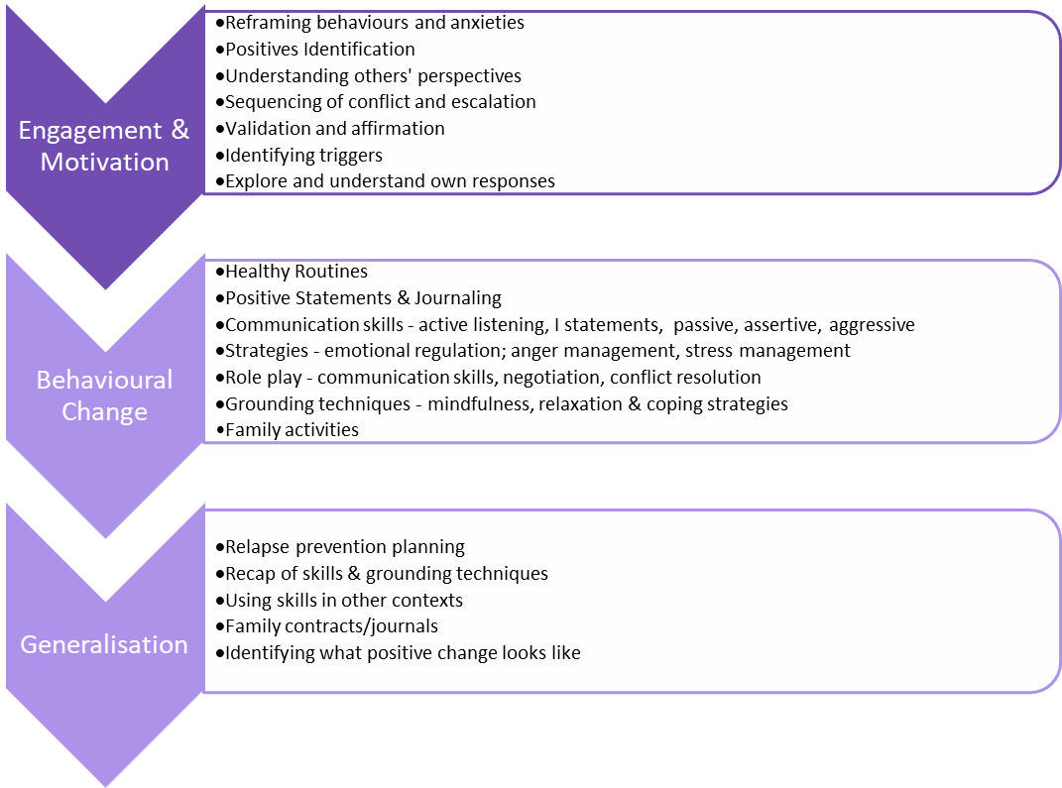

* 1. Case notes demonstrate a progression: from detailed work to enable families to reframe and understand behaviours and responses; through the development of communication skills, parenting approaches, healthy routines, and grounding techniques; completing with a review and recap of skills developed and how they might be used within wider contexts and to help sustain change.

|  |
| --- |
| **Engagement and Motivation**  “We did some reframing of behaviour, point processing, and re-labelling of emotions”.  “We used relational statements, discussed the impact of interrupting and diverting”.  “We talked through sequences of conflict and the different functions and meanings that behaviour may be expressing”. |
| **Behavioural Change**  “We developed family contracts to manage arguments, allow space and be respectful of one another, and identified consequences if the contract was broken”.  “We role-played different communication styles”.  “We introduced a strategy for cooling off (knocking twice on front door means 'I don't want to talk about why I'm angry' so there was time to calm down before the conversation starts)”.  “We identified healthy eating and sleep hygiene strategies – addressing Maslow basic needs”.  “I encouraged the family to have time to bond – through family games and cooking sessions”.  “We reviewed grounding techniques (e.g., Listen to surroundings, short walks, mediation, music, breathing strategies)”. |
| **Generalisation**  “We started to think about how different circumstances may bring about situations when they may slip into old ways or patterns of behaviours”.  “We agreed what successful change would look like e.g., positive situation at home, positive relationship between family members, boys attending to school, oldest child having a job”.  “We produced a Relapse Prevention Plan – identifying triggers, thoughts & feelings, skills - for each family member”.  “The family developed their own approach building on the skills learnt - journaling to provide a manual for each individual to refer to, to help have a greater understanding of each other”. |

* 1. Case notes, closure forms and the in-depth case studies evidence some changes for many families as a result of these actions, including:
  + **Better relationships and communication** within the family.
  + **Conflict resolution and de-escalation**.
  + **Improved behaviour from young people within families**.

**Young people had been supported to develop their own skills, for example:**

* creating plans for managing their emotions;
* learning techniques for deescalating problems/how they feel;
* learning how to achieve outcomes without negative behaviours.

“The session where me and mum listened to each other and understood each other was really helpful”.

“The young person talks more openly about their emotions and verbalises problems”.

“The young person is now included in family time and their deportment has changed from withdrawn to more positive and engaged”.

**Parenting skills and strategies have also been developed, for example:**

* learning to give other space to calm down to avoid arguments;
* developing clearer and more confident boundaries;
* use of/understanding behaviour/reward systems;
* accessing support networks, including school liaison.

“There is evidence of emotional validation from mum to the young person since the last session, which is a huge step forward”.

“The parents are better at managing their children’s behaviour positively”.

**Families have been supported to:**

* understand each other’s needs;
* articulate individual needs;
* consider different reasons for behaviour & make connections.

“The siblings remain emotionally regulated when having family time”.

“Better empathy and understanding between family members have led to sustainable change”.

“He understood how his behaviour was perceived by his sister as well as his mum”.

“The I Statements and giving each other space has helped us reduce arguments and improve the atmosphere at home”.

“The SF intervention helped to break the cycle of negative behaviour”.

## Factors Influencing Effectiveness

* 1. **Figure 3.2** summarises some of the features of the therapy and delivery approach identified by stakeholders as working well.

Figure 3.2: Features of Stronger Families

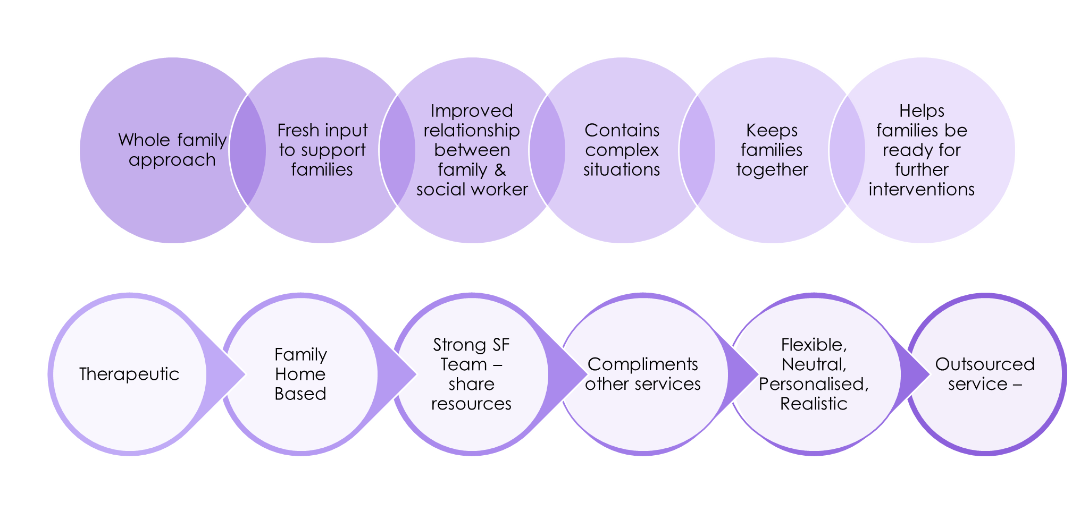

* 1. Features of the therapy that families and other stakeholders commonly identify as working particularly well, helping to make a difference for them, include:
  + **Addressing issues with the family all together**, rather than individually.

“Focusing on the family dynamics and working with us together, rather than separately, has meant we can learn and practise skills with each other together”.

“The exercises allowed for self-reflection and took away aspects of blame from any one individual”.

* + Focusing on the **root cause of issues**, including past traumas and outside influences on the family.

“The therapist dealt with the root cause of conflict within the home and encouraged real change”.

* + Allowing time for **self-reflection and understanding of impact on others**, as well as **reframing others’ behaviours**.

“Mum understands better how her own behaviour/responses are not helpful and has sought to change this”.

* + Helping to **develop core communication skills**, and to **practise these as a family** rather than separately.

“I found the skills taught in how to understand and communicate with my child were particularly helpful”.

* 1. Aspects of delivery that influence effectiveness include:
  + **Time spent and skills used by therapists** to:
  + **Build rapport** with all family members, demonstrating a genuine interest in them.
  + **Tailor approaches** to individual family interests and needs.

“The therapist spent time understanding the family dynamics and was able to tailor activities to our needs”.

“The therapist seemed to have a genuine interest in the family”.

* + **Flexible approach to engaging** with individual family members.

“The older sister was involved in therapy when home for University”.

* + **Providing individual skills development** alongside family therapy where appropriate and feasible.

“The therapist provided some CBT with the older child, helping to reframe behaviour and thoughts.”

* 1. **Parent/carer readiness and openness to engage** with the therapy has also been important in supporting the positive delivery of therapy and change achieved.

## Outcomes for Service Delivery

* 1. Some referring practitioners pointed to ways in which liaison with Stronger Families had some positive impacts on broader ways of working with and supporting vulnerable families.

“I really enjoyed the closing session with the therapist and the family, it was something we do not do enough and has inspired me to try and do this more often, to leave on a positive note.”

“Therapists have attended CiN meetings to report on their findings which has been really useful. They also regularly update the database with notes so the social work team can track engagement”.

“It was really helpful when the therapist came to family network meetings to discuss progress”.

“Stronger Families gives me more time to focus on my role – supporting the young person”.

# family changes and outcomes achieved

* 1. Here, we outline the changes experienced and outcomes achieved for the families engaged with the Stronger Families FFT intervention. We draw on intervention evidence for 21 intervention evidence cases (IECs) completed (including 4 case studies which triangulate perceptions across therapists, referring practitioners and families). The IECs represent 30% of the 70 completed closures up to March 2021.
  2. We consider below each of seven themes from the theory of change (Appendix B):
* C1: Change in risky behaviour (young person and/or parental behaviours).
* C2: Change in family functioning.
* C3: Change in strengths and difficulties experienced by the young person; and their impact on home life, friendships and relationships.
* O1: Outcomes relating to avoidance of care.
* O2: Outcomes relating to improved engagement in education.
* O3: Outcomes relating to improved health, and in particular, mental health (of young person and/or parents).
* O4: Outcomes relating to reduced offending.

## C1: Risky Behaviour

* 1. There is good evidence from case notes and satisfaction questionnaires to **suggest an improvement in young peoples’ behaviours since the Stronger Families intervention** began – 60% of IECs saw a positive change in behaviour, and 20% saw some improvement. In the other cases, behaviours were the same at the end of the intervention – none indicated that behaviours had worsened.

“….is generally calmer and any arguments that do occur do not become physical in nature”.

“Issues are handled appropriately and at the right time instead of escalating to physical and verbal aggression”.

“Some improvement in behaviour – though he continues to have some verbal outbursts, he is no longer physically aggressive”.

“The risk of criminality has severely reduced”.

“There is more stability at home”.

“There is a greatly reduced level of conflict and violence within the home”.

* 1. There is also some indication that parents/carers have **improved their parenting approach and skills** (again, in about 60% of IECs). Several young people identified in their questionnaires that parents/carers had changed the way they responded to them. Parents also commented on their improved skills and in some cases feeling “*more empowered”* and *“more in control/better able to cope when difficult situations do arise”:*

“…. mum is no longer leaving the children alone and uses the parenting strategies developed with the therapist”.

“It feels like I can be the parent I used to be and want to be again”.

“…[she] better understands her own responses and offers an improved parenting response as a result”.

“Parenting approach has improved which means there is a reduction in incidents of poor behaviour from the children”.

“…. [I am] better able to manage [child’s] behaviour through consistent parenting techniques”.

“Communication skills have improved impacting positively on the family dynamic”.

“I observed changes in mum’s responses and management of the boys’ behaviour”.

## C2: Family Functioning

* 1. Triangulation of qualitative and quantified data (case notes, satisfaction and Score 15[3] questionnaires completed by young people and parents/carers, and stakeholder perceptions from case studies) indicates **improvements in family functioning resulting from Stronger Families FFT amongst the IEC families**. This is evident for two-thirds (14) of the completed cases, with some improvement seen for a further three families. In two cases, family functioning is thought to have remained the same, but worsened for the remaining two families.
  2. Changes seen include:
  + More **positive interaction and better relationships** between young people and their parents/carers; and between siblings.

“Mum and [child] are much more affectionate with each other – [child] will go and sit on her lap and they cuddle up more in sessions”.

* + **Reduced intra-family conflict and a calmer atmosphere** – fewer arguments, with skills developed to diffuse situations where they do arise.

“The atmosphere at home is generally calmer but when tensions do arise the family are able to diffuse situations, giving each other space to calm down effectively”.

* + More effective **communication skills developed**:
  + Young people better able to communicate their worries and anxieties in a constructive rather than hostile or aggressive way.

“It’s become second nature to communicate openly about my feelings”.

* + Parents/carers and young people can better explain how they feel and talk more openly about it.

“a significant improvement in their ability to communicate and these skills are now part of daily interactions with each other”

* + **Healthier routines** for eating, sleeping, and use of technology, for example.
  + Greater **awareness and understanding of each own and other’s emotions** and triggers.

“These skills are now part of daily interactions with each other”

* + **Increase in time and quality of time spent** together as a family.

“[they] enjoy spending time together, which they couldn’t do before, with mum describing [child] as ‘fun to be around’”.

* 1. There are also indications from a number of the IECs, that the **change experienced is being embedded helping to sustain the positive impact** for the family over time:

“The first time the family has been able to sustain change over a period of time”.

“I have observed the family integrating the learning from the therapy into their day to day lives”.

“The communication skills developed are now part of our daily interactions with each other”.

“The siblings remain emotionally regulated when having family time”.

“Better empathy and understanding between family members have led to sustainable change”.

## C3: Strengths and Difficulties

* 1. Emotional and behavioural strengths and difficulties questionnaires[4] (including the ‘impact supplement’[5]) were completed by both young people and their parent/carer at the start and end of the Stronger Families therapy (we have completed data from 13 young people and 12 parents/carers, enabling assessment across 15 IECs in total).

* 1. A **positive change in the impact of emotional and behavioural strengths and difficulties** for young people was reported for seven of the IECs (**just under half** of those that we have completed data for). Some of the perceptions gained through the case studies and responses from the satisfaction questionnaires with young people help to illustrate how the therapy has helped to achieve this change:

“…. the youngest boy is able to understand and link his aggressive outbursts to how he is feeling, which he was unable to do before”.

“I am managing my anger 40% of the time now”.

“Being able to deal with sticky situations and a better way to talk to each other”.

“A session where me and my mum were listening to each other and understanding each other”.

“The therapist has given me insight into my problems and made it better. I feel better about myself”.

“[child] now seeks help when experiencing mental health difficulties – the strategies the therapist has helped to put in place means he knows what to do and who to discuss the appropriate actions with”.

* 1. In three cases a worsening picture for overall distress and impairment was reported by parent/carer and/or the young person themselves. In other cases, the picture was more mixed (young people reporting a positive change but parents/carers reporting a negative change; or vice versa) or reflected no change in either direction.

## O1: Avoidance of Care

* 1. A core intended outcome from Stronger Families FFT is to support a reduction in the need for young people to enter (and stay in) Care. To provide some understanding of the extent to which this has been achieved we have considered both the quantitative data regarding changes in social care category[6] alongside triangulated evidence obtained from a review of the case notes and perceptions from key stakeholders.
  2. Overall, there is good qualitative and quantitative evidence to suggest that Stronger Families FFT is having a positive impact on the avoidance of care outcomes for young people and families:
  + Programme data shows a **Iower care entry rate for those successfully completing Stronger Families FFT** (6%), compared to those who dropped out of the intervention (19%).
  + **‘Avoidance of care’** or **‘reversal of trajectory towards’** outcomes has been supported through Stronger Families FFT in **52% of all IECs**.
  1. Below we outline further our assessment and evidence relating to the extent to which Stronger Families FFT has achieved avoidance of care outcomes. The table below summaries the changes in social care status since Stronger Families FFT began for the 21 completed IECs.

**Table 4.1: Social Care Status[7] of 21 Completed Evidence Review Cases**

|  |  |  |  |
| --- | --- | --- | --- |
| **IEC Case** | **Intervention Start** | **Intervention End** | **Current (April 21)** |
| 1 | CIN | CAF | EH |
| 2 | CAF | CAF | CAF |
| 3 | CAF | CAF | None |
| 4 | CAF | CAF | CAF |
| 5 | CPP | CIN | EH |
| 6 | CPP | CPP | EH |
| 7 | CAF | CAF | CAF |
| 8 | CPP | CIN | CAF |
| 9 | CAF | CIN | CIC |
| 10 | CIN | CAF | CAF |
| 11 | CIN | CIN | EH |
| 12 | CPP | CIN | CAF |
| 13 | CPP | CIN | CIN |
| 14 | CAF | None | None |
| 15 | CIN | EH | EH |
| 16 | CAF | CAF | CAF |
| 17 | CPP | CIN | CIN |
| 18 | CAF | CAF | CAF |
| 19 | CAF | CIC | CIC |
| 20 | CIN | CIN | CIN |
| 21 | CIN | CIN | CIN |

Source: Suffolk Stronger Families Programme Data, April 2021

### Edge of Care

* 1. The question of whether a young person was on the Edge of Care at the point at which therapy began should be used as a starting point to consider the broader question of whether care has been avoided or not as a result of the intervention received. Answering these questions, however, is fraught with difficulties given their subjectivity and the inevitable differing interpretations between both the professionals supporting families and the families themselves.
  2. In other evaluations of this nature, a young person is generally not considered to be on the Edge of Care unless they are subject to a CPP. At the programme level – 100% of completed cases that were CPP at the start remained out of care; compared to 79% of early closure CPP cases remaining out of care.
  3. In addition, **all the IEC cases** **that were CPP** at the start of therapy (six or 30% of the IECs) had been stepped down (2 to CIN, 3 to CAF, 1 to other) by the end of Stronger Families FFT, and therefore might be **considered as having ‘avoided care’**. This compares to an average monthly ‘step-down’ from CPP rate of 16% (and net change accounting for step-ups of 10%) between March 2019 and February 2021 at Suffolk County level[8].
  4. In half of these cases there is good qualitative evidence that the **therapy contributed** considerably,and in two cases, contributed to some extent **to this avoidance of care – so in 24% of our IEC sample.**

“Stronger Families are invaluable. They save us money – three young people would have gone into supported accommodation without it. In all cases the Stronger Families therapy prevented it”.

“It was the SF therapist working alongside social services (me) that helped to contain and hold the family”.

“Stronger Families has helped a great deal - all our needs have been met and the young person’s behaviour has improved significantly”.

“Stronger Families helped a great deal, improving behaviour and family relationships considerably”.

“The young person feels considerably better about self and acts differently as a result. Parents comment on a considerable improvement in behaviour, with new skills developed to manage any conflict that arises. There has been a positive change in the way they get on as a family”.

“The carer is now more supportive of the young person’s education; and they spend more time together as a family in response to reduced conflict and tension”.

### Trajectory to Care

* 1. For those cases that did not begin as CPP (nine IECs had open CAFs and were engaged with Early Help services at the point of referral and six were children in need (CIN)), there is evidence from the case notes and triangulated perceptions that many could be considered as **“on the trajectory towards” care** (or, for older children, supported housing) at the start of therapy.

“Early Help team consider the family to be at risk of family breakdown and that the boys were on a trajectory towards care if relationships were not improved”.

“Family breakdown may mean [child] will move to a hostel”.

“Mum is regularly asking [child] to leave and not return”.

“Mum said [child] may need to leave home and move into supported housing”.

* 1. A further third of IECs have seen their social care status stepped down since the start of Stronger Families FFT. This includes:
  + Four of the six that were CIN when referred that have stepped down to CAF or closed – 67% stepped down, compared to the average monthly step-down from CIN at County level of 29% (16% net) between March 2019 and February 2021.
  + Two of the nine with an open CAF at referral which have now been closed to Early Help services – 22% stepped down, compared to the average monthly step-down from CAF at County level of 50% (40% net) between March 2019 and February 2021.
  1. In all six cases (30% of our sample) the Stronger Families FFT is considered to have had an **influence**, considerable in some cases, **on the change in direction for these families** – representing a further **28% of our IEC cases**.

“Stronger Families has been instrumental in achieving change for this family: this is the first time the family have been able to sustain change over a period of time”.

“The family would not have achieved such positive change without the therapist – she has come with a magic wand”.

“Mum now feels more confident when caring for the children and there is no risk of family breakdown or care entry”.

“SF intervention was central to the change and achievements for the family, who had previously felt let down by social services”.

“The young person was on the trajectory towards care entry at the point of referral, as mum felt so unable to cope with his behaviour – as a result of Stronger Families there is now no risk of care”.

“There have been no safeguarding concerns from school or MASH since Stronger Families started working with the family”.

### Entering Care

* 1. In two IEC cases (**10% of the 21 completed IECs**), the social care status has escalated with the young people **having now entered care**. This represents a slightly higher proportion than for the current status of the full completed case sample (4 of 70 (just under 6%) are now in care or independent living).
  2. In both IEC cases, however, Stronger Families therapy is considered to have helped the families “somewhat”, but in one case the intervention was too late and in the other whilst relationships were improved, ongoing safeguarding concerns resulted in the young person being taken into care.

## O2: Engagement in Education

* 1. In seven IECs (one third), stakeholders have observed, or case notes referenced, an improvement in the young person’s engagement with education and/or attendance at school; in four cases educational engagement has worsened or stayed poor. For six cases there had been no particular concerns regarding the young person’s engagement in education; and for four cases there was no clear evidence.

“Both children now attend school full-time which is a huge improvement compared to their near refusal before the intervention”.

“The youngest child is now doing well at school and the school noticed a difference in both boys”.

“The older child has quit drugs and is now attending a training programme”.

“The young person is no longer withdrawing when in school and is engaging better with peers”.

## O3: Health

* 1. Core 10 and OQ45.2 questionnaires have been completed by families receiving Stronger Families FFT, at the start and end of the therapy. They are both validated tools providing some indication of overall mental health for young people and parents/carers respectively, including consideration of feelings about self, anxiety, interpersonal difficulties and satisfaction and quality of life.
  2. Comparison of pre and post scores indicates some improvement in mental health for parents/carers in nine cases, six of which show considerable change. Similarly, for young people improvements are seen in nine cases, with considerable change observed in three cases. Overall scores have worsened in two cases for parents/carers and three cases for young people.

“The young person now seeks help when experiencing mental health difficulties – this is in stark contrast to before the intervention when he would self-medicate with drugs. He knows now what to do and who to discuss appropriate actions with”.

## O4: Offending

* 1. There are some qualitative references to the young people referred being less at risk to being exploited or involved in criminal activity at the end of therapy.

“The young person has quit drugs, is no longer engaging with criminal groups and there is no criminal investigation ongoing”.

* 1. However, we have not been able to access or gain insight into any other sources of evidence for this key outcome.

# cost avoided measures

* 1. Here we consider some of the issues to be taken into account when developing measures of cost avoided for Stronger Families FFT in Suffolk. These could be set against the business as normal intervention costs to provide some fiscal return on investment assessment. The development of this approach is something that would need to be discussed further with the steering group, if it was to be taken forward.
  2. The core variable to consider for cost avoided measures for Stronger Families FFT in Suffolk is **‘Care Avoided’**. There is a lack of consistent quantifiable and verified data to provide an assessment of the other potential themes, such as improved education and offending outcomes; though there may be some value in looking at more detail in the Core 10 and OQ45.2 measures.
  3. The Suffolk SIB model assumption is that 45% of completed cases would have avoided care anyway without any intervention from Stronger Families FFT. The programme data shows a gap between into-care rates for families that completed the therapy compared to those that dropped-out:
  + 6% of completed cases entered care (by March 2021) compared to 19% of early closure cases (a difference of 13%).
  + Looking just at those cases that were CPP at the start of therapy, there is a greater difference (21%) – 100% of those completed therapy remained out of care, compared to 79% of those who dropped out.
  1. There may be, of course, other factors that impact on the avoidance of care for the Early Closure cases, such as impact achieved through the therapy that was undertaken, or other interventions and support being put in place as a result. Equally, as discussed in the preceding section, case notes and perceptual evidence indicate that the Stronger Families FFT had contributed to some avoidance of care in **just under a quarter of the IECs**. It will therefore be important to take a further look at programme data after a year; and two years to assess any change or widening of the into care gap between completed and early closure cases (and other appropriate comparison groups).
  2. Once a figure for avoided care has been established, we would need to identify some cost avoided proxies, which can be done via the nationally recognised Unit Cost Database which YCL have access to. We would need to consider up to three potential cost variables – residential care, fostering care, or supported living.

1. Norfolk.gov.uk News 2019
2. Stronger Families cases were divided into three cohort groups – Cohort 1 included families first referred between February to September 2019; Cohort 2 families were referred between October 2019 and March 2020, and Cohort 3 families were referred between April 2020 to April 2021.
3. Score 15 is a self-report measure of family functioning and has been proved to be a reliable and valid index of therapeutic change. SCORE can be read in terms of second order change; structural change; change in the stories the family members have about their family; change in systemic processes within the family; in an orientation to solutions; improvements in relation to hopefulness, agency, hostility, risk, blaming, well-being, happiness and so on.
4. The questionnaire (developed by Goodman, 1997; Goodman et al, 1998) screens for child emotional and behavioural problems while focusing on a child’s emotional and behavioural strengths as well as difficulties. It incorporates five scales: pro-social, hyperactivity, emotional problems, conduct (behavioural) problems, and peer problems.
5. The impact supplement sums items on overall distress and impairment to generate an impact score that ranges from 0 to 10, and reports the impact of difficulties, upset or distress in relation to home life, friendships, classroom learning and leisure activities.
6. Children with an open Child Assessment Framework (CAF), assessed as a Child in Need (CIN), subject to a Child Protection Plan (CPP) or is a Child in Care (CiC).
7. CIN = Child in Need. CPP = Child Protection Plan. CIC = Child in Care. CAF = Children Assessment Framework. EH = Early Help.
8. Calculated from Suffolk County Council social care data, April 2021