Life chances fund - Functional guidance

This functional guidance is created for Life Chances Fund projects to support them to upload their information to the DCMS platform. There are four main steps to take and each will be broken down into instructions and screen shots.

Grant Management

For successful LCF projects, when you log in you will now see the Grant Management homepage. From the here you can access:

- Offer letter baseline (read-only)
- Payment profile (read-only)
- Outcome achievement and payment claim form - filled in every 3 or 6 months
- Annual monitoring form - filled in annually
- Applications - previously submitted EOI, full application and set up form
- Outcome achievement and payment claim history - previously submitted forms
- Annual monitoring history - previously submitted forms

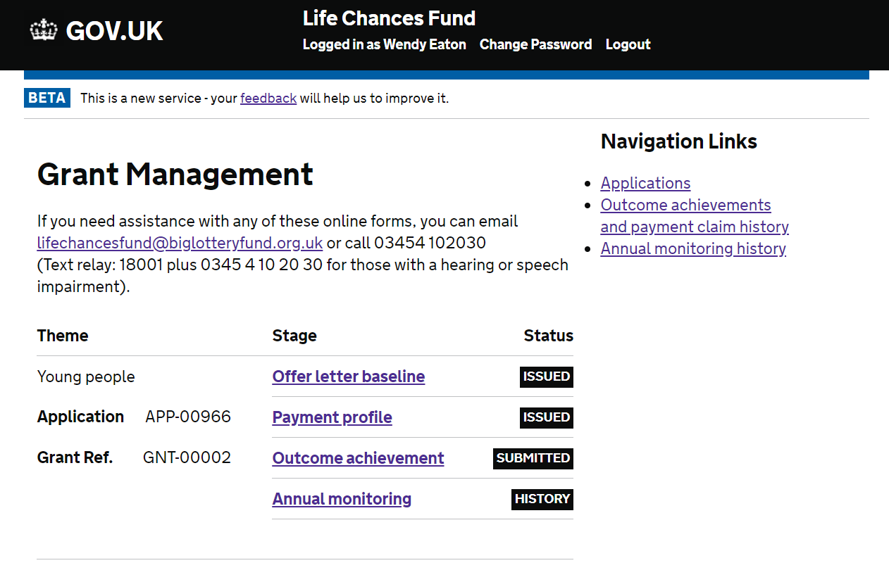

Offer letter baseline

- The offer letter details are uploaded by the funding officer and appear as read-only.
- To see the details of the offer letter, click on the ‘Offer letter baseline’ link then click ‘View all answers’ or ‘Print all answers’ (highlighted below).
- To get back to the homepage, click ‘Grant Management’ in the breadcrumbs at the top of the page.
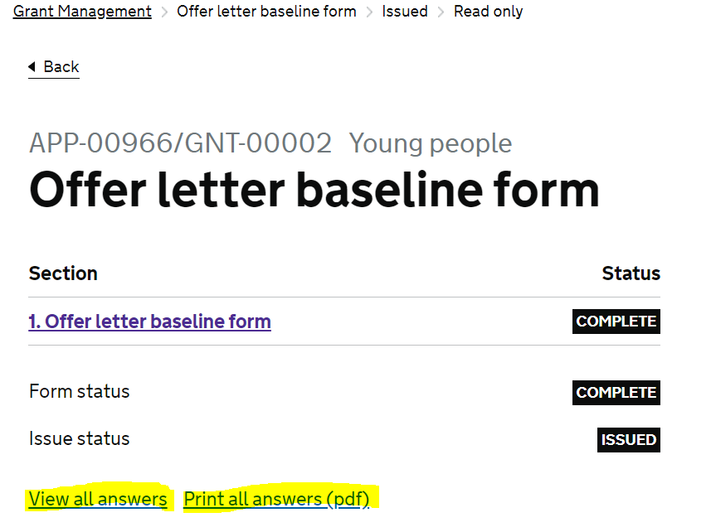

Payment profile

- The payment profile is uploaded by the Funding Officer and appears as read-only.
- To see the details of the payment profile, click on the ‘Payment profile’ link > ‘1. Payment profile’ (highlighted below) > ‘Start section’ > then click on the document link to download it.
- To get back to the homepage, click ‘Grant Management’ in the breadcrumbs at the top of the page.
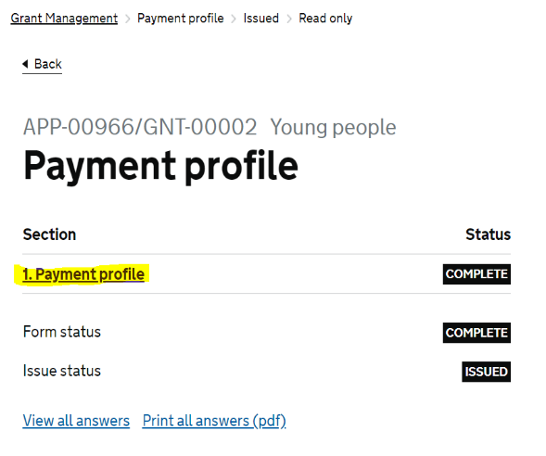

Outcome achievement and payment claim

- This form can be completed every 3 or 6 months, you’ll be asked to provide details of your progress towards achieving outcome and details of your payment claim.
- You will need to work through each section before submitting.
- The four areas to work through are: Service user referrals, Outcome targets and achievements, Outcome payment and Payment declaration and authorisation.

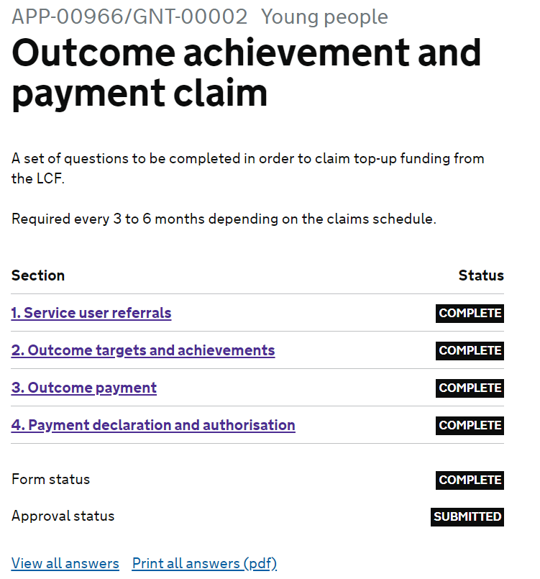

3a. Service user referrals

This section will collect the data regarding referrals to your service during the reporting period.

- Click on the blue hyperlink to enter the area
- You will be presented and asked to fill in your claim period, this can be a length of 3 or 6 months
- You will also need to provide details on the amount of service users you’ve engaged with in this period
- You will be provided with a summary page when you have completed all questions should you wish to change any answers please select change
- Any questions you have missed will show with a blank answer, you must complete these before you can continue
- When all necessary sections are complete and you are ready to move onto the next section click ‘Mark section as complete and continue

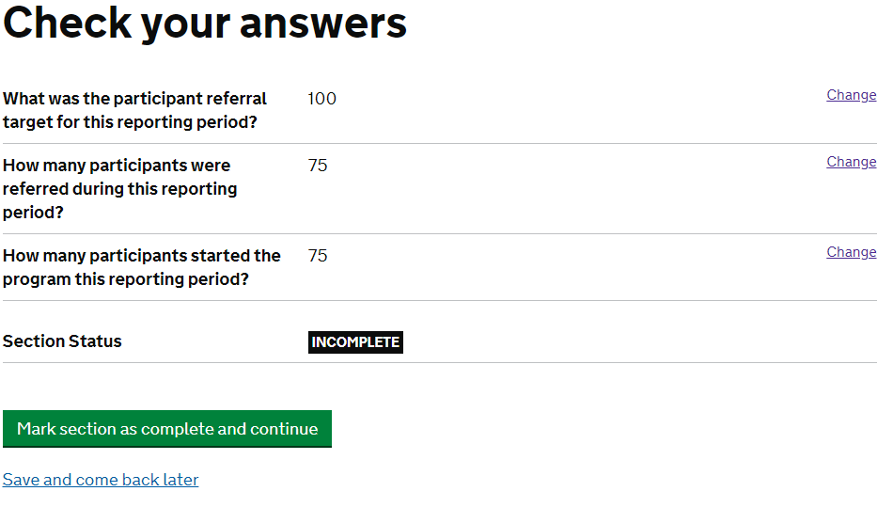
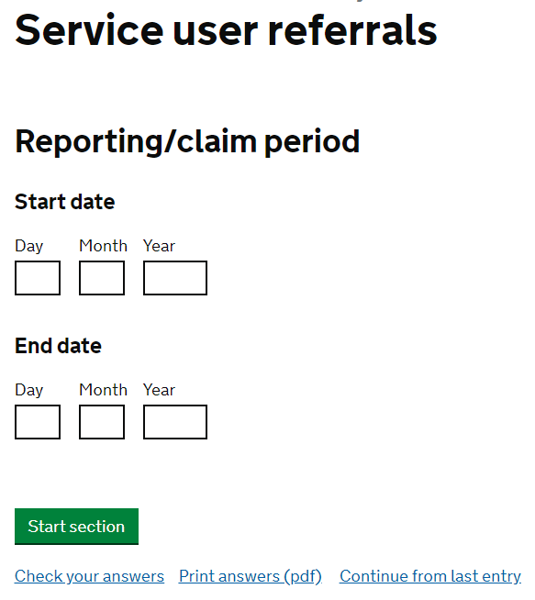

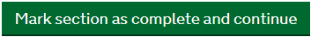

3b. Outcome targets and achievements

This section is where we’ll collect information regarding your outcome targets, achievements and payment details for the reporting period.

- Click on the blue hyperlink to enter the section
- The reporting period will already be pre-populated from the previous section
- After clicking the ‘Start Section’ button you will be presented with your outcomes
- Click on the blue hyperlink for each outcome to enter data regarding the achievement of outcomes in this claim period
- If there has been no achievement within an outcome then please enter ‘0’
- Once you’ve entered your data you will see it summarised and calculated on main screen
- Press ‘Save and continue’ to move forward
- You will be present with a final summary page
- Should you wish to change any answers please select change
- Any questions you have missed will show with a blank answer, you must complete these before you can continue
- When all necessary sections are complete and you are ready to move onto the next section click ‘Mark section as complete and continue’.

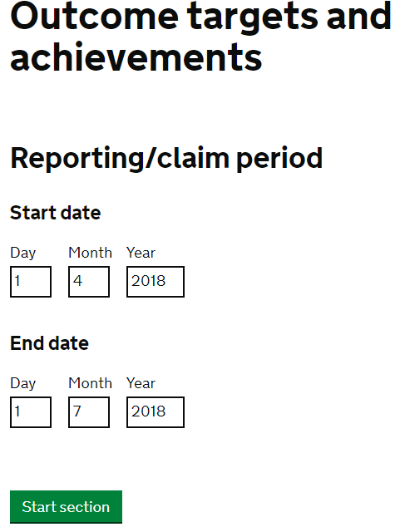
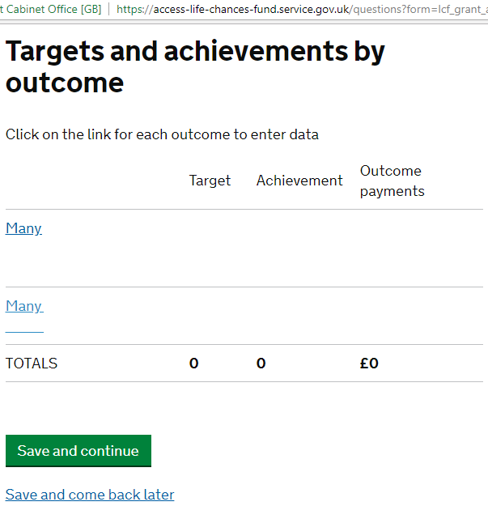

3c. Outcome payment

This section is where you will submit your LCF Top Up claim.

- Click on the blue hyperlink to access the Outcome Payment area
- The reporting period will already be pre-populated from the previous section
- After clicking the ‘Start Section’ button you will be asked a series of questions regarding your top up
- You will be presented with your outcomes
- Click the blue hyperlink to enter the outcome and record details of your top up claim against that outcome
- If there is no claim please put zero in the box provided
- Once complete you will see your outcome payments total and LCF Top Up totals (shown below)
- Click Save and Continue
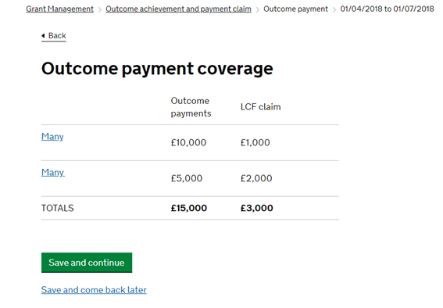

- You will next be asked to provide details of your claim against each payment trigger. They will be listed, click on the blue hyperlink to enter each payment trigger area
- The final three questions will ask you to upload documents to verify your payment claim. These must be uploaded before we can verify your claim, the system will not prompt you and will allow you to complete the section without these documents.

3d. Payment declaration and authorisation

The final section you will be asked to complete is the payment declaration and authorisation

- Please complete all details, you will be presented with a review section once complete.
- Please mark the section as complete when you have completed all required information.
- When ready click ‘submit’ to send your claim.

Your Funding Officer will review the information you provide and get back to you with any questions or queries. Once agreed your payment will be made, it will usually be paid into your bank account on a Friday.

Please note when you are ready to submit your next claim, click the archive button which will archive the last form and open up a new one.

NB. This button will only appear when the Funding Officer has approved your previous form
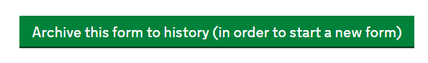

- To view previous forms go to the grant management homepage and click the Outcome achievement and payment claim history link on the top right.

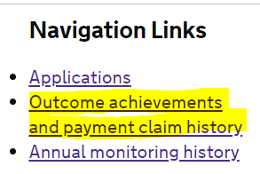

Annual monitoring form

- This form is completed annually by the user.
- User works through the sections and then submits for approval.

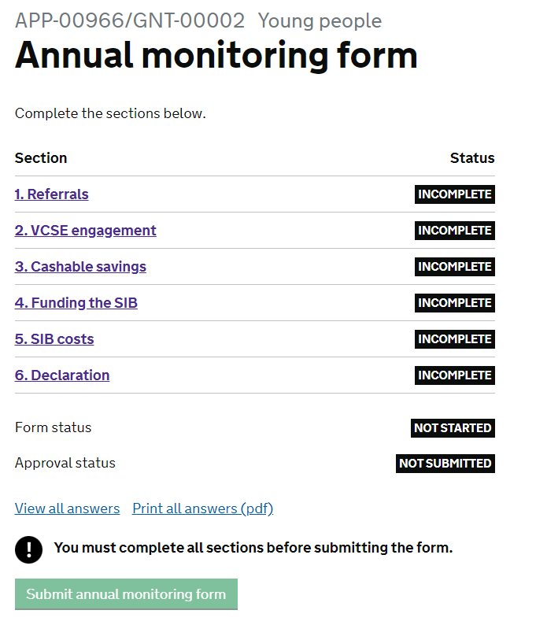

4a. Referrals

- Click on the blue hyperlink to begin the section
- You will be asked to provide the ‘Financial year end date’ on the first screen, this is the last date of the financial year you are reporting back to us.
- Click Start section to begin
- You will be asked a series of questions regarding your cohort, these questions must be completed to continue
- You will be presented with a summary page of your answers, when you are happy with your answers click ‘Mark section as complete and continue’

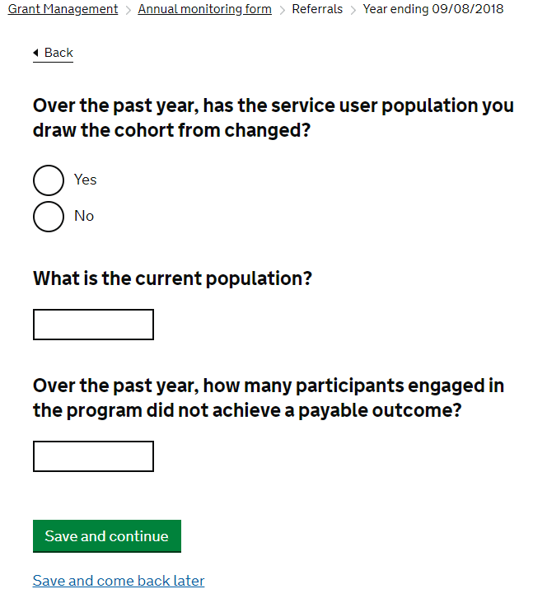

4b. VSCE engagement

In this section you will be asked a series of questions about your VCSE Engagement over the last year

- The ‘Financial year end date’ screen will appear and pre-populated from the previous section. Click ‘Start section’ to begin
- You will be asked a series of questions regarding VCSE involvement in your SIB over the last 12 months. If the answer is no to one of the questions, please put a zero
- You will also be asked about any additional engagement with VCSE organisation, if your answer is ‘yes’ the page will expand to ask for some additional details

- On the final screen you will be presented with a summary page of your answers, if you wish to change any answers click on the blue hyperlink ‘change’.
- When you are happy click the ‘Mark section as complete and continue’

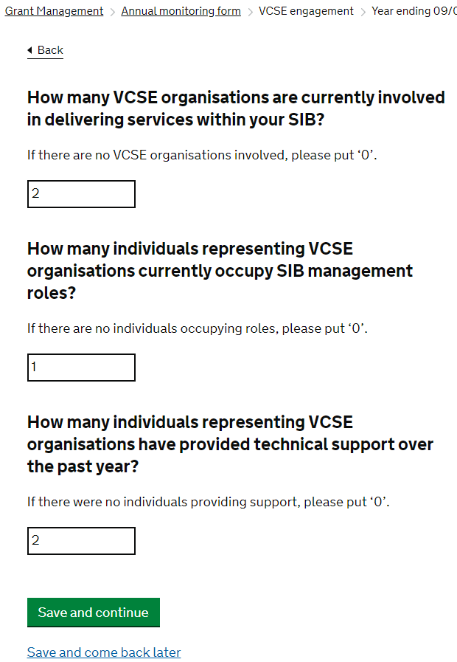

4c. Cashable savings

In this section you will be asked to provide information around the Cashable Savings your SIB has made in this reporting period

- The ‘Financial year end date’ screen will appear and pre-populated from the previous section. Click ‘Start section’ to begin
- You will be asked to provide details of your ‘Cashable Savings’ from this reporting period and how you have calculated these figures. Please provide as much detail as possible
- The next section will ask if you have any other cashable savings or costs avoided to other local commissioners and the local community. If there has been savings this reporting period, you will be provided with additional boxes upon clicking ‘yes’ to capture this information

- The next section will ask if you have any other cashable savings or costs avoided to central government. If there has been savings this reporting period, you will be provided with additional boxes upon clicking ‘yes’ to capture this information
- On the final screen you will be presented with a summary page of your answers, if you wish to change any answers click on the blue hyperlink ‘change’.
- When you are happy click the ‘Mark section as complete and continue’
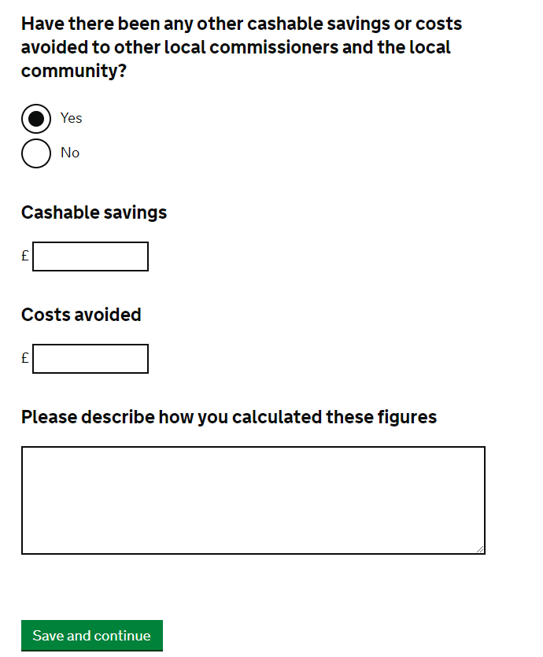

4d. Funding the SIB

In this section you will be asked to provide the details of the total outcome's payments received in the past year from Life Chances Fund and Other Commissioners

- The ‘Financial year end date’ screen will appear and pre-populated from the previous section. Click ‘Start section’ to begin
- You will next be asked to provide details of the funding you have received to help fund the SIB in this reporting period. If the answer is ‘zero’ to any of the questions, please populate with a zero

- On the final screen you will be presented with a summary page of your answers, if you wish to change any answers click on the blue hyperlink ‘change’.
- When you are happy click the ‘Mark section as complete and continue’

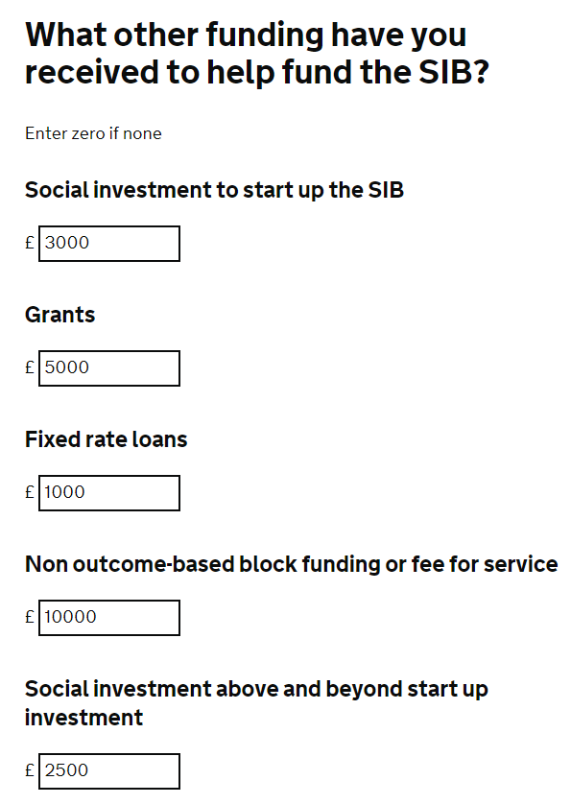

4e. SIB costs

In this section you will be asked to provide financial information regarding the delivery costs for your SIB over the last year

- The ‘Financial year end date’ screen will appear and pre-populated from the previous section. Click ‘Start section’ to begin
- You will be asked to provide details of your anticipated and actual delivery costs, please ensure your anticipated costs reflect what you have previously reported to us during set up
- You will be asked to supply details of the amount you have spent on evaluation and learning over the past year. We anticipate that SIB will have evaluation plans in their budget and would not expect to see ‘zero’ expenditure in this area

- The next question will ask for information about your anticipated cost of SIB performance management and actual. The anticipated cost should reflect figures you will have provided to us previously
- The next question asks for details about your Social Investment including how much you have leveraged and return rates
- The final section asks if you need to revise your payment profile
- If you wish to revise your payment profile, click yes and you will be taken to a page where you can upload your new version
- If you have revised your funds flow since your final application please click ‘yes’ and upload an updated version
- On the final screen you will be presented with a summary page of your answers, if you wish to change any answers click on the blue hyperlink ‘change’.
- When you are happy click the ‘Mark section as complete and continue’

NB: If you do need to revise your payment profile or funds flow please speak to your Funding Officer before uploading to the system

4f. Declaration and authorisation

The final section you will be asked to complete is the payment declaration and authorisation

- Please complete all details, you will be presented with a review section once complete.
- Please mark the section as complete when you have completed all required information.
- When ready click ‘submit’ to send your claim.

Your Funding Officer will review the information you provide and get back to you with any questions or queries.

- When you are ready to submit the next annual monitoring form, click the archive button which will archive the last form and open up a new one.

NB: This button will not appear until the funding officer has approved the form

- To view previous forms go to the grant management homepage and click the ‘Annual monitoring history’ link on the top right
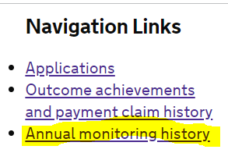

- End of grant – if this is the final year of the grant the user should tick the box at the start of the Referrals section (see below) which will open up an extra section in the annual monitoring form.

